**FOUNDATIONS OF STATISTICS: – ASSIGNMENT – 2**

**Name: SYED OMAIR MAQDOOM MOHIUDDIN ID: 102863768**

**Question 1:**

An Organisational psychologist at an institution hypothesised that the average score for “team engagement” of Australian public service employees has decreased due to changes made by the current government when the average score was 14.5 (as per the previous research).

For a random sample of 1500 Australian public service employees, the average score for “team engagement” was 11.71 (s = 6.06 [rounded to two]). This is lower than the mean score of 14.5 which was recorded in the previous research and a one-sample t-test shows this difference in mean score for “team management” is significant, t(1499) = 17.82, p < 0.001.

The 95% confidence interval shows that average score for “team management” of Australian public service employees is between 2.48 and 3.09 less than the score of 14.5.

As expected, the average score for “team management” of Australian public service employees has decreased when compared with the previous research.

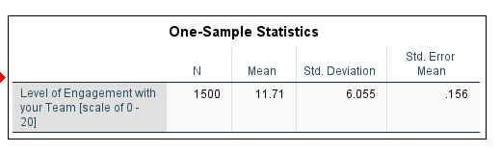

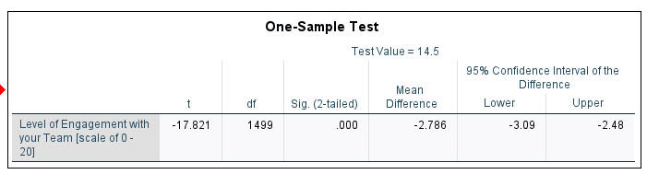

**Additional Output:**

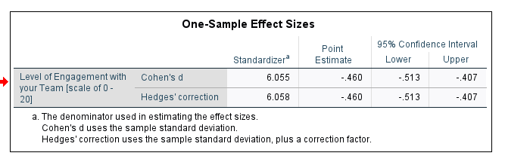

**Question 2:**

Researches hypothesised that Australian public service employees who have less than 5 years tenure in their job are more engaged with their supervisor than Australian public service employees who have 5 years or more tenure.

For a random sample of 1493 Australian public service employees, the average level of engagement with their supervisor for the employees who have less than 5 years tenure in their job (M = 14.11, s = 5.06, n = 450) was higher than the average level of engagement with their supervisor for the employees who have 5 years or more tenure (M = 13.47, s = 5.22, n = 1043), however an independent sample t-test shows this difference in mean level of engagement of Australian public service employees with their supervisor is significant, t(1491) = 2.18, p = 0.029.

The 95% confidence interval shows that the average level of engagement of employees with their supervisor who have less than 5 years tenure in their job is between 0.07 and 1.21 higher than for those who have 5 years or more tenure.

As expected, the average level of engagement of Australian public service employees with their supervisor who have less than 5 years tenure is higher than that of employees who have 5 years or more tenure.

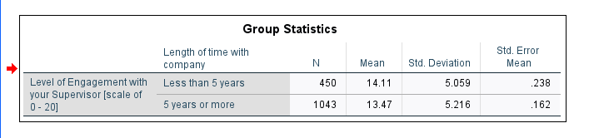

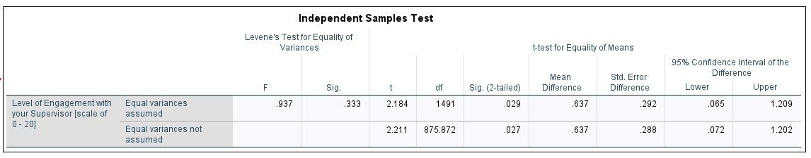

**Additional Output:**

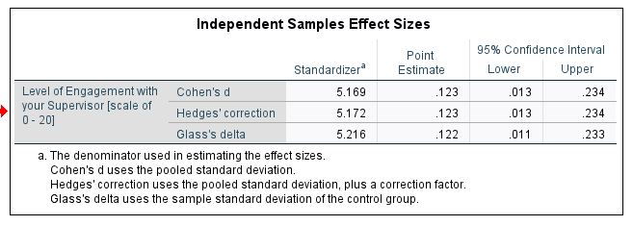

**Assumptions:**

The assumption of independence of observations has been met. The sample was a random sample of Australian public service employees. The assumption of normality has not been met. The distribution of level of engagement of employees with their supervisor was negatively skewed for those who have less than 5 years tenure. The distribution of level of engagement of employees with their supervisor was negatively skewed for those who have 5 years or more tenure. The assumptions of homogeneity of variances has been met. The Levene’s test was not significant (Sig. > 0.05). The independent samples t-test is robust to the violation of either the assumption of normality, or the assumption of homogeneity of variances, so the results of the independent samples t-test can be used.

Additional output to check assumptions:

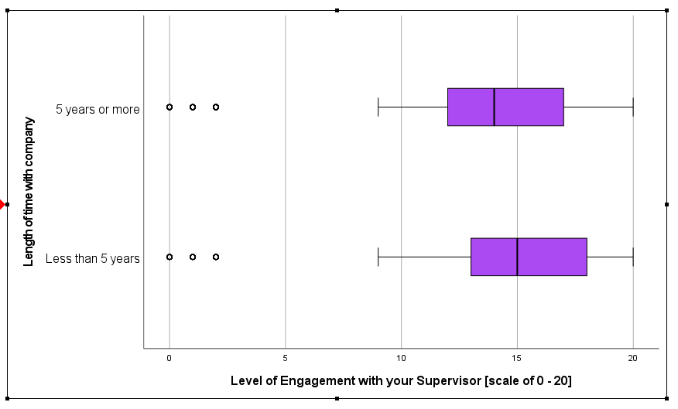

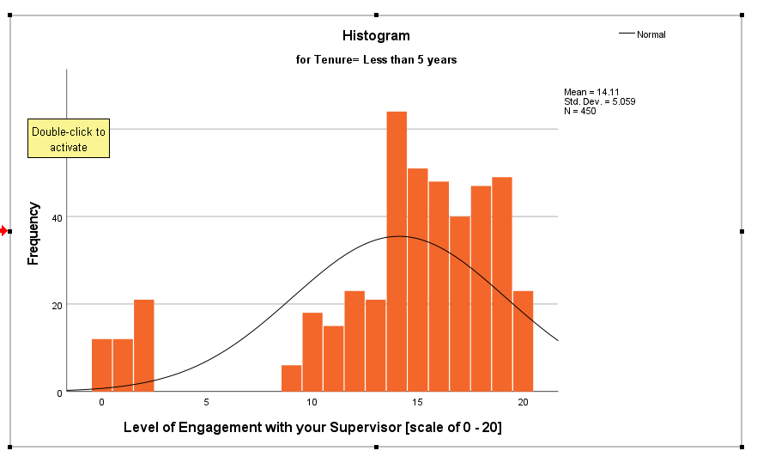

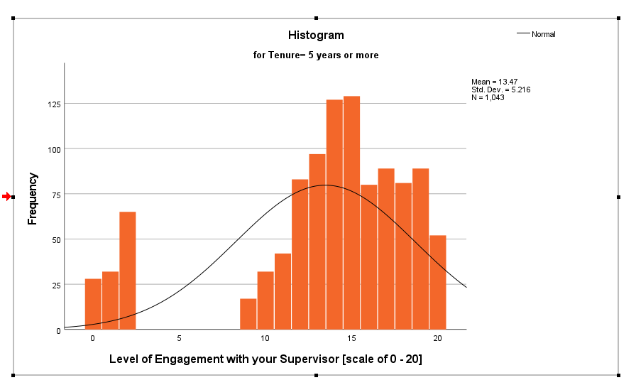

**Question 3:**

Researchers hypothesised that Australian public service employees are more engaged, on average, with the team of colleagues they regularly work in than with their supervisor.

For a random sample of 1493 Australian public service employees, on average, the level of engagement with their supervisor (M = 13.66, s = 5.18) was higher than the level of engagement with their team (M = 11.71, s = 6.05). A paired samples t-test shows that this difference in the mean of level of engagement of employees (MD = 1.95, sD = 5.97) is significant, t (1492) = 12.62, p < 0.001. The 95% confidence interval indicates that, on average, the level of engagement of employees with their supervisor is between 1.65 and 2.25 scores higher than the level of engagement of employees with their team.

Contrary to the expectations of the researches, the level of engagement of the Australian public service employees with their team is less when compared with the level of engagement with their supervisor. They have higher level of engagement with their supervisor than that of with their team.

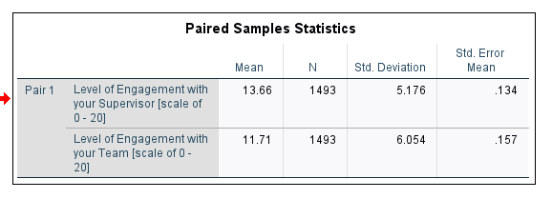

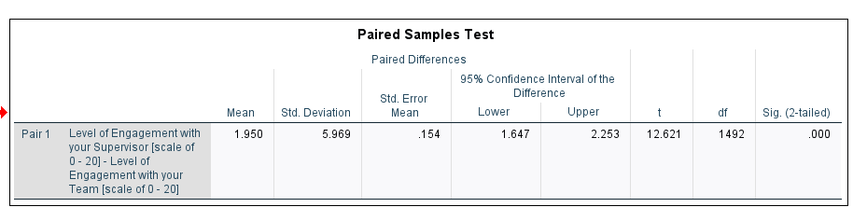

**Additional Output:**

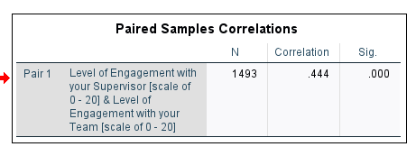

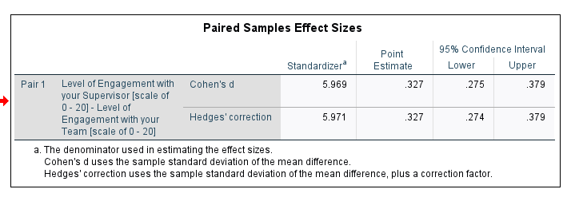

**Assumptions:**

The assumption of independence of observations has been met. The sample was a random sample of Australian public service employees. The assumption of normality has been met. The distribution of the difference scores was approximately normal.

[or]

The distribution of the difference scores in the sample appear to be normally distributed which suggests that in the population the difference scores are normally distributed.

Additional output to check assumptions:

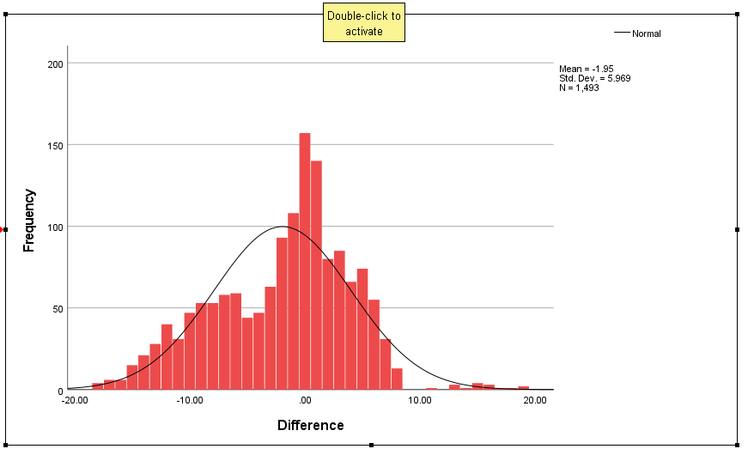

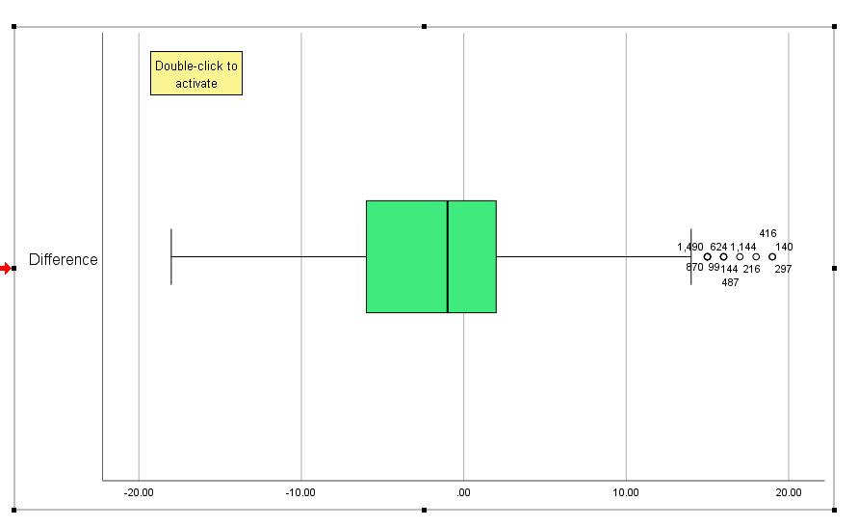

**Question 4:**

1. To investigate the pharmaceutical company’s prediction, we conduct a Binomial test (Comparing our sample proportion to a population proportion known) for a single proportion using z-standard normal distribution. Where the H0 and H1 are:

**H0**= There is no difference in the proportion of Australian adults who prefer to take a generic brand prescription drug

**H1**= There is a difference in the proportion of Australian adults who prefer to take a generic brand prescription drug

1. The population contains all the **Australian adults**. All Australian adults is the population we can draw conclusions about in this study.
2. Given p = 0.110, when we compare the p value with the **∝** (0.05) value, p value is greater than the value of ∝ (0.11 > 0.05). We assume 5% level of significance that is ∝ = 0.05. So, it is not significant. We do not reject the null hypothesis[**H0**].

The conclusion of the pharmaceutical company is correct. The percentage of Australian adults willing to take a cheaper generic brand prescription drug has remained the same, exactly 48%.